**Question 1: How many locations of your selected store are open in the DFW MSA? Provide documentation indicating the number of open stores.**

* There are 26 stores open in the DFW MSA.
* 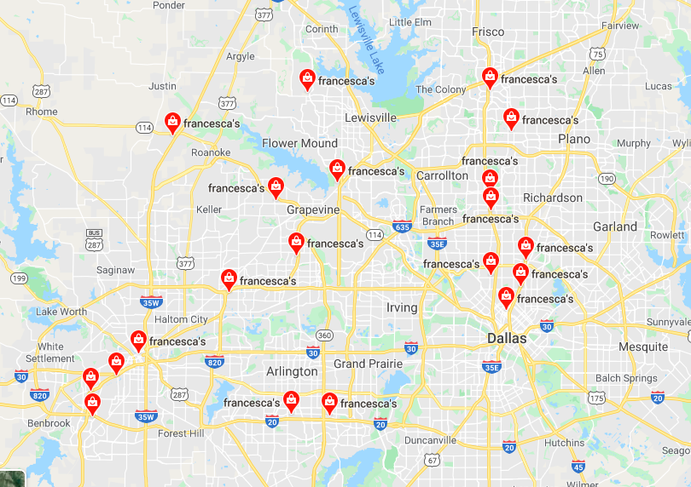The first map picture shows the locations of the first 20 stores
* The second map picture shows the location of the next 6 stores

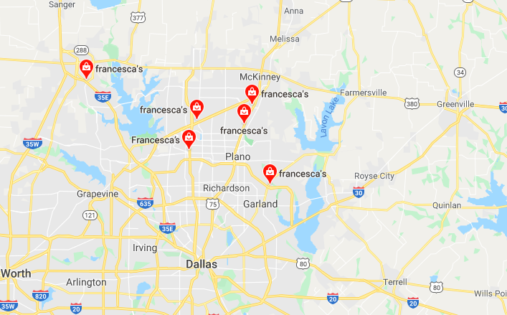

* The addresses of all 26 stores can be found below:
  1. 400 Commerce St, Fort Worth, TX 76102
  2. 1600 S University Dr #604, Fort Worth, TX 76107
  3. 4800 S Hulen St, Fort Worth, TX 76132
  4. 5330 W Lovers Ln #112, Dallas, TX 75209
  5. 3900 Arlington Highlands Blvd Suite 173, Arlington, TX 76018
  6. 5240 Marathon Ave, Fort Worth, TX 76109
  7. 5307 E Mockingbird Ln #105, Dallas, TX 75206
  8. 13350 Dallas Pkwy #2415, Dallas, TX 75240
  9. 3699 McKinney Ave suite 501, Dallas, TX 75204
  10. 15837 North Freeway Service Rd W East, Fort Worth, TX 76177
  11. 8080 Park Ln N Suite 105, Dallas, TX 75231
  12. 2950 Interstate 20 #445, Grand Prairie, TX 75052
  13. 5100 Belt Line Rd A20, Dallas, TX 75254
  14. 1101 Melbourne Rd #3052, Hurst, TX 76053
  15. 1200 Chisholm Trail #700, Euless, TX 76039
  16. 214 State St, Southlake, TX 76092
  17. 3000 Grapevine Mills Pkwy #133, Grapevine, TX 76051
  18. 1400 Shoal Creek #170, Highland Village, TX 75077
  19. 1900 Preston Rd Suite 203, Plano, TX 75093
  20. 7201 Bishop Rd Suite E - 9, Plano, TX 75024
  21. 245 Cedar Sage Dr, Garland, TX 75040
  22. 2601 Preston Rd #1055, Frisco, TX 75034
  23. 2201 S Interstate 35 S-12, Denton, TX 76205
  24. 843 Watters Creek Blvd, Allen, TX 75013
  25. The Shops at Willow Bend #6686 121 W. Park Blvd 1, Suite A219, Plano, TX 75093
  26. 820 Stacy Rd #632, Allen, TX 75013

**Question 2: Looking at the “Evaluating Specific Sites” provide detailed information relating to the five ‘Site Characteristics’ as they pertain to your selected store.**

* The selected store of Francesca’s is at the Shops at Legacy (7201 Bishop Rd Suite E - 9, Plano, TX 75024 ).
* **Traffic and accessibility**: The Francesca store at shops at legacy is located between legacy drive and Tennyson parkway, and on the other side there is Dallas Parkway and Parkwood boulevard. There are multiple entry points to the shopping center so there is a lot of traffic on the road due to the residential area and offices that are situated above the shops at legacy. Due to that there is always a lot of foot traffic that can be seen during the daytime. There is easy access because It can be accessed from the Dallas parkway when you are travelling west. When traveling west on Dallas Parkway, you get connected to legacy drive and when driving towards east on legacy drive there are multiple entry points. Better times of day to visit the shops at legacy would be on the weekends or before 4 pm on weekdays. After 4pm on weekdays the traffic on legacy drive, Dallas parkway tends to be bus. During the time lunch hour which is usually 12pm-1pm there is more traffic on the legacy drive. There will be constant foot traffic in between the shops since the shopping center is a lifestyle type of center. From the accessibility point of view there are 3 entrances from legacy drive, 4 entrances from Parkwood Blvd., 2 entrances from Tennyson pkwy and 3 entrances from Dallas pkwy. There are 2 street lights on legacy drive with are connected to bishop road and Parkwood Blvd. The bishop road goes straight to the store. Even from Dallas pkwy there is a connecting road named Kincaid road which also directly leads to the store. Having 2 street lights at legacy drive gives accessibility to enter the shops at legacy. While on Dallas pkwy the road diverges into 2 roads enabling me to go to store easily without a street light. Since there is always so much foot traffic, Plano city council constructed a 14-foot divided pedestrian walkway and a 14-foot bicycle pathway that stretches over the tollway. The project includes pedestrian traffic signals, lighting and five-foot buffers to separate foot traffic from vehicle lanes. There is also a U-turn lane north of legacy drive that connects the tollway frontage roads. This project was funded in 2017 and thus helped mitigate some of the impending traffic concerns.
* **Parking:** The parking spaces around the store on the street is limited such as 3 to 4 spaces, like 3 spots on bishop road and 3 spots on Kincaid road. But behind the store there is a parking garage which has 4 floors of parking spaces. The parking spaces are straight spaces which increases the like hood of accidents since the car can go in either directions while getting out of the space. The worst time for parking at shops at legacy would be around 8am and 5pm because that when all the office deployment people arrive and leave which creates traffic. Better days for parking would be Sunday and Saturday before 12pm since there is not a lot of traffic going on.

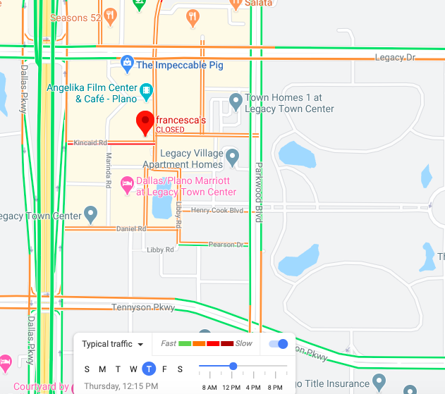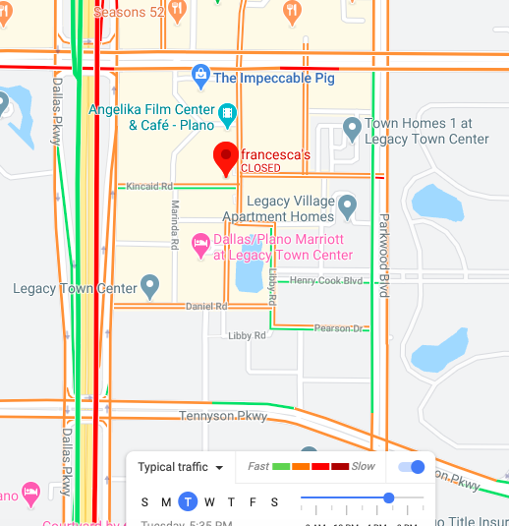

* **Visibility:** The ability to see the store from the street is a little hidden by the trees as you can see in the picture. The signage is a little more visible from the side of the store which is on Kincaid road. But the definition of visibility has been changing since everyone nowadays have smartphones and have the accessibility to reach the store with step by step instructions given from the maps.

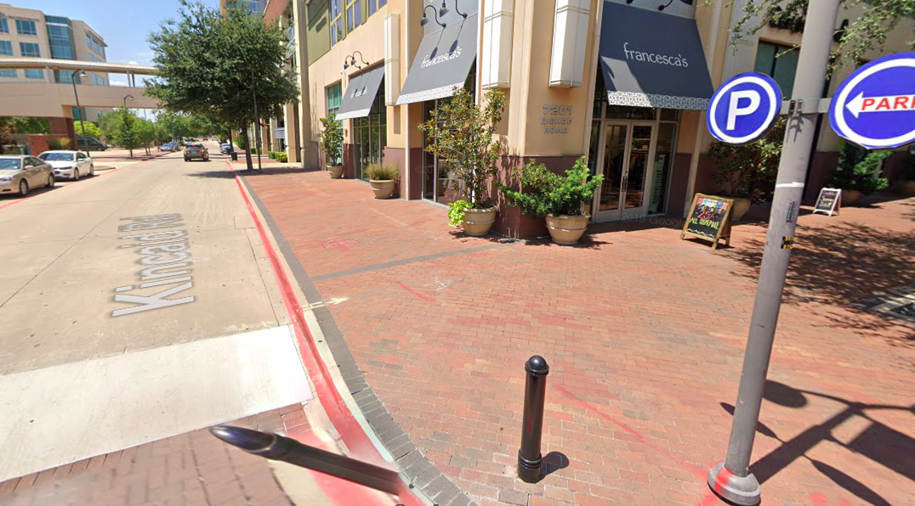

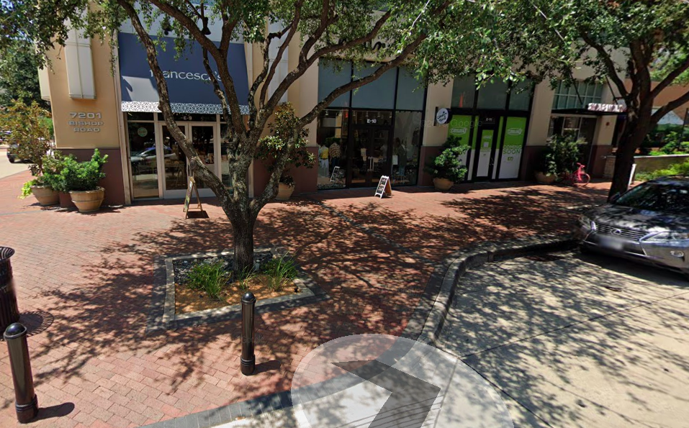

* **Adjacent tenants:** My store being Francesca’s has both competing and complementary retailers. Some of the complimentary retailers are Milk bubbles, Oil and vinegar (jewelry and gift store), Flirty girl lash studio, Solitaries, Shumi omakase (Japanese restaurant) and many more. People shopping at Francesca’s would most likely shop at oil and vinegar for jewelry options. They could also visit the flirty girl lash studio for a lash lift. And after they are done shopping they could have sushi at Shumi omakase. Thus complementing the store in a way that they make the shopping experience for the customer wholesome. The competing retailers are all clothing and apparel retailers. Francesca has unique styled clothing for women with a variety of shoes, bags, jewelry and accessories, and the competing stores such as Apricot lane boutique, Cousin Earl, Ella Bieu, Firefly Trends, Joni’s Boutique, Scout & Molly’s Boutique, Urban Outfitters and y&i clothing boutique provide these merchandise.
* **Restrictions and cost:** At the shops at legacy most of the retailers and restaurants are high-end. Most clothing retailers are boutiques that have unique styled clothing or tailored clothing. There are restaurants that are cheap such as Starbucks, chipotle and Jamba juice. Therefore at shops at legacy you would not find low-income stores because the residential area around it has high income and can afford the merchandise from these stores.

**Question 3: Define the primary, secondary, and tertiary trading area for your selected store. Provide justification for all three trade areas.**

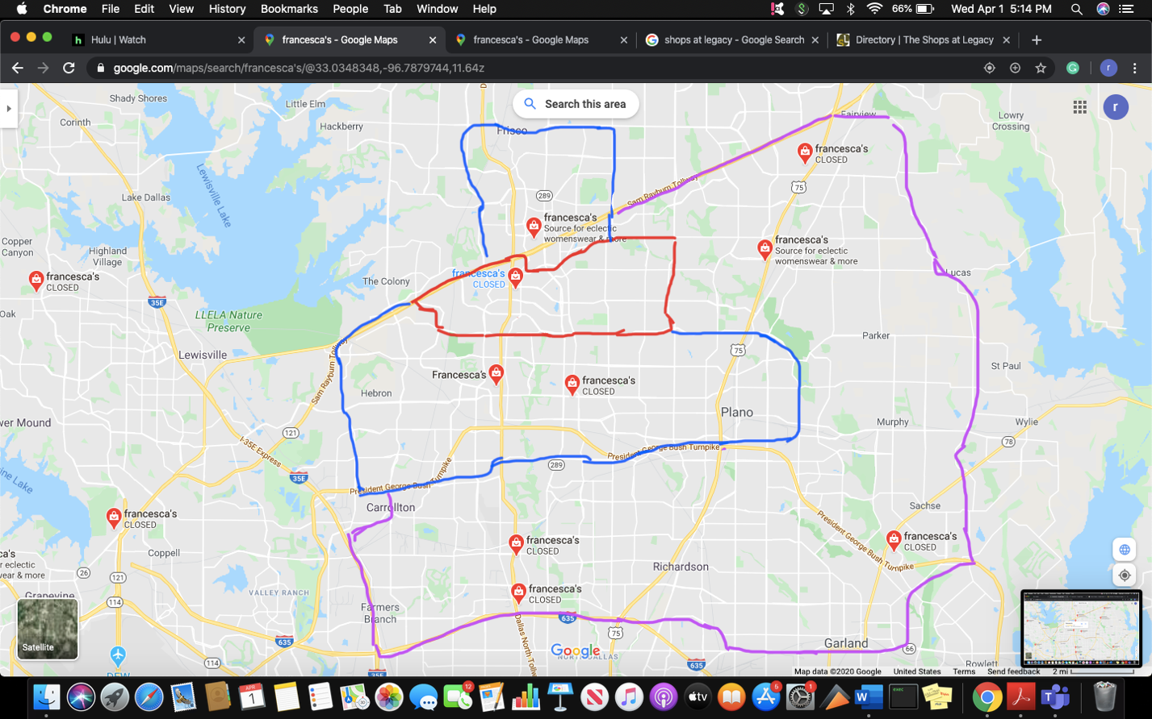

* The primary trading area is marked by red, secondary trading area is marked by blue and tertiary trading are is marked by purple.
* The **primary trading area** is good distance for all the nearby apartments that are situated. There is diverse set of people who live in this area are willing to go to the store marked in the red area because it would take them on average 5-8 minutes from their home. There are office developments at shops at legacy therefore people leaving work at 5pm could be visiting the store therefore making the store accessible to them from their place of work. I believe that the primary trading area is good because it covers at least 60 percent of the customers of the stores. The trading area might seem small but it is to kept in mind that many residential areas are located very close to the store.
* The **secondary trading area** stores are located within the time frame of 8-10 minutes. Considering the traffic on Dallas north tollway and legacy drive it would take 10-15 minutes to reach the store which is well within an adequate time frame. The secondary trading are covers 2 stores south, and 1 store north of the primary trading store. Many young individuals tend to live farther from their pace of work in order to save on rent thus the secondary area seems fit for them. They are willing to travel further for some unique styled clothes especially tailored for them.
* The **tertiary trading area** consists of stores that are more than 15 minutes of drive. Our tertiary trading area consists of 2 stores south, 1 store east and 2 stores north of our primary trading store. These stores are widely distributed and thus takes a little longer for these customers to reach our primary store. This area also consists of cities such as Carrolton, Richardson, Framers Branch and Garland. These cities have a lot of graduated individuals who are willing to travel farther. Also there can be some instances where the collections of merchandise would be different and thus enabling them to come to the primary trading store (shops at legacy).

**Question 4: Using the regression analysis approach to estimating potential sales for a store site, what are five factors (variables) that you think are most important for predicting store sales at your selected store? Explain!**

* First factor to be considered for a new store site is demographics mainly consisting of age and income level of the population. If opening a store site, the population living around the store should be between the age of 21-40 years with an income level on an average $89,000 - $95,000. These are the people who can afford the high-end merchandise from Francesca’s store. These customers are the appropriate target market for high-end stores.
* Second factor to be considered whether the population living near the store are graduate professionals. Psychographically graduate professionals would be a great target market since they are entering the workforce environment and are stepping up into a new lifestyles of professional attire rather than jeans and college t-shirts. Therefore their tastes and attitudes towards clothing would change and thus having a store near them would enable them to purchase merchandise.
* Third factor to be considered would be accessibility. Making the store accessible to the customers through public transport could be huge factor. Parking could also be taken into consideration. If the store does not have enough parking then the customer would not want to drive there because there are no parking spots available.
* Geographic location of the store matters as well. Supposedly if the target market lives in Plano while the nearest store to them is 25 minutes away. Then opening a store within the 15 minutes of their range would be beneficial since the target market would actually go to store to buy the merchandise.
* Tenants around the store is also a factor that should be considered. If there are complementing stores such as a nails salon, a coffee place or a jewelry store would drive women to go there since all their needs are being met in one shopping center. If there are men apparel store and salons for men, it would enable married couples to come together since both of them could have fun at the center. Restaurants, bars, furniture stores, postal services and other services would make a wholesome experience for the customer and would draw them to them since they don’t have to go anywhere else. Saves them time and gas. Complementing stores would be a factor to be considered.